Created a file Second.txt and added three lines

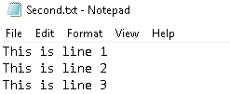

Committed and push the 3 lines to github

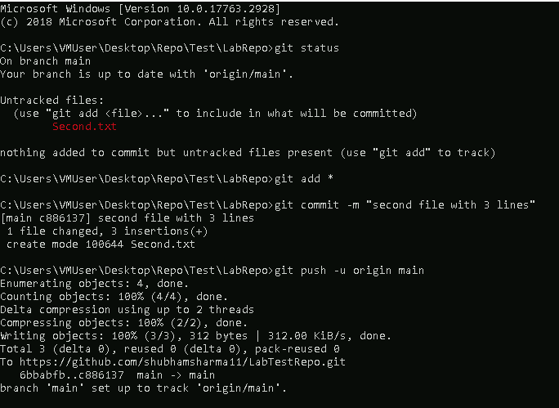

Stash 4th and 5th lines separately

Add the 6th line and commit

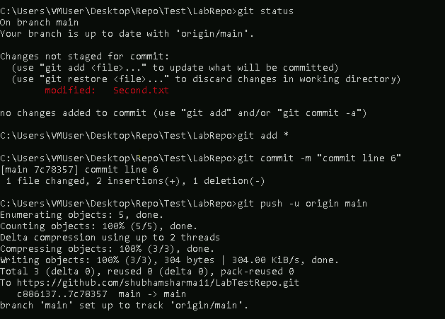

Add back the 5th line from the stash and commit

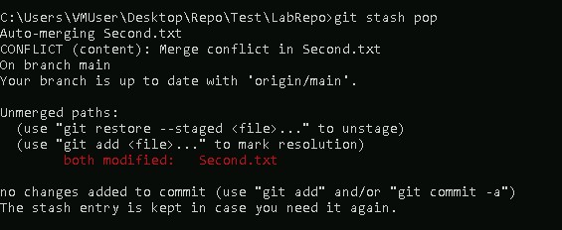

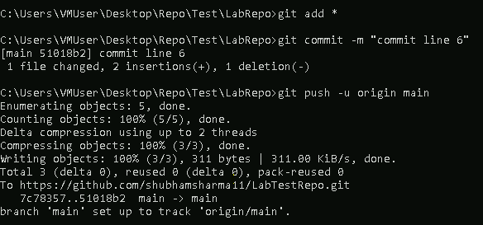

Add back the 6th line from the stash and commit but stash should remail saved

